Neel et al. Data Results – Spring 2021
Sample Characteristics:
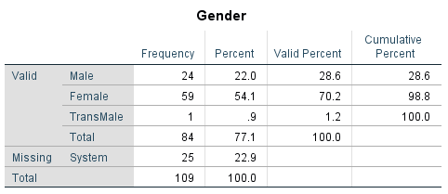
Age:
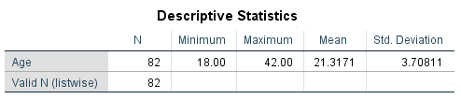

Correlations Between Self-Protection and Other Individual Difference Variables [compare with top part of Table 3 in the Neel et al. paper]
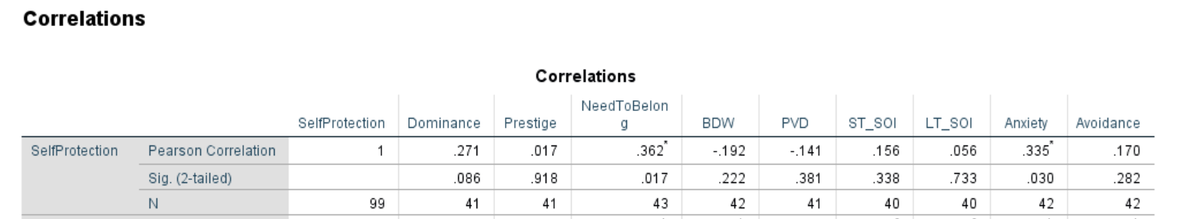

Correlationas Between Mate Seeking and Other Individual Difference Variables [compare with top part of Table 3 in the Neel et al. paper]

Correlations Between Self Protection and Big 5 Personality Traits [compare with bottom part of Table 3 in Neel et al. paper]:

Correlations Between Mate Seeking and Big 5 Personality Traits [ compare with bottom part of Table 3 in Neel et al. paper]:

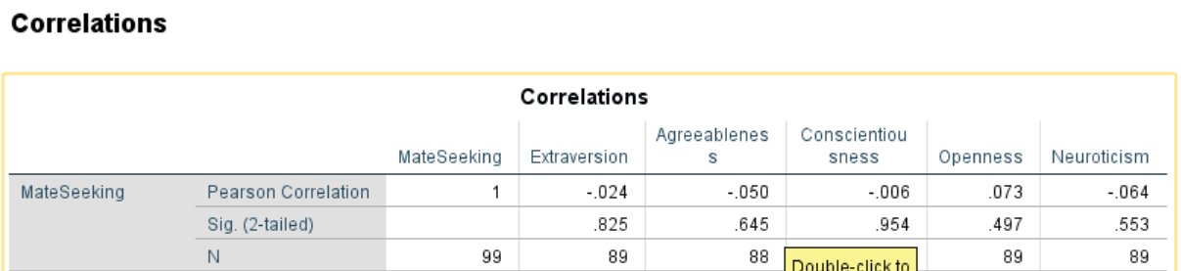

Regression Analysis for Self Protection:
Overall Model Statistics [Compare with bottom part of Table 4 of the self protection table in Neel et al.]:
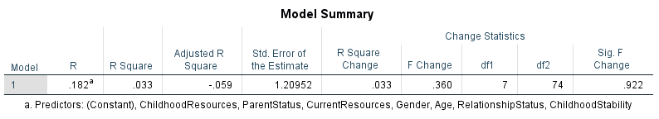
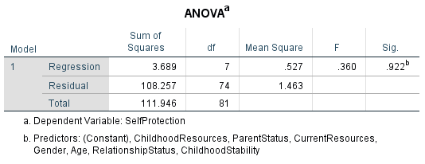

Data on Individual Predictors for Self Protection:
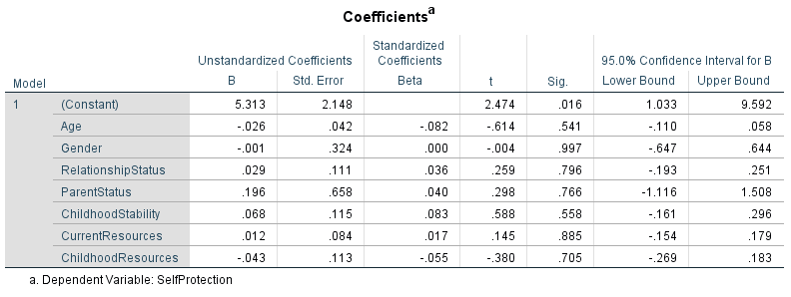
Regression Analysis for Mate Seeking:
Overall Model Statistics [Compare with bottom part of Table 4 of the mate seeking table in Neel et al.]:
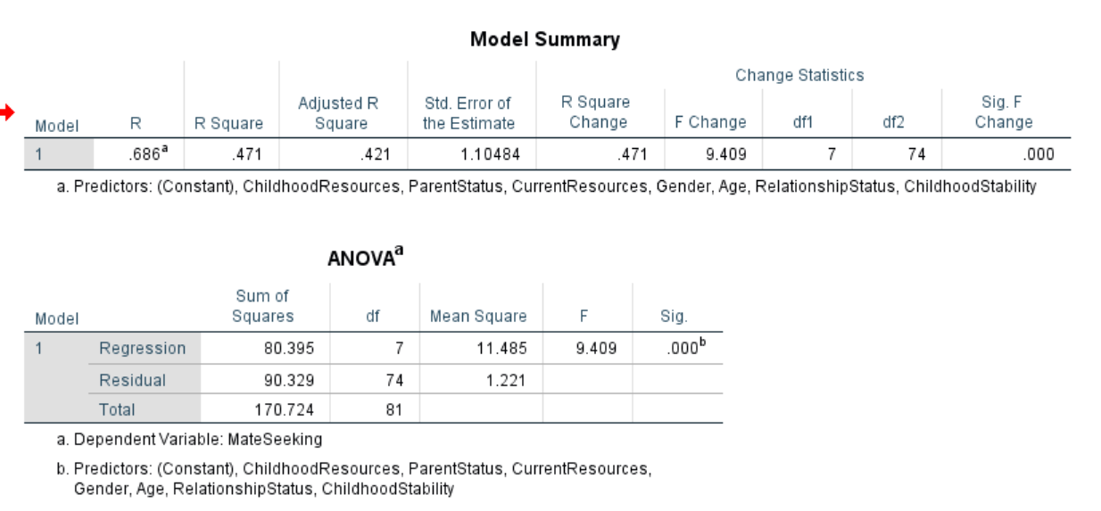
Data on Individual Predictors for Mate Seeking:
